**AN ARDL APPROACH ON TAX AND ECONOMIC GROWTH IN INDIA**

* **S. RAJIV 205PGE033**

*Abstract*

This study investigates the relationship between economic growth (GDP) and tax using the Auto-Regressive Distributed Lag (ARDL) bound test approach. The study further shows the relationship between the exchange rate and net exports, examining the effect of each of them on economic growth. The data for the study were obtained from the Reserve Bank of India (RBI) Handbook of Statistics and the World Bank bulletin, spanning from 1994-2018. In the model, the logged value of the GDP growth rate was integrated of order zero whereas the tax rate, exchange rate, and net exports were found to be of integrated order one. The ARDL results show no cointegration among the variables. Results of the study show that taxes and exchange rates show negative but a small significant effect on economic growth in the short run and long run. Net exports have a positive impact on economic growth in both periods.

*Introduction*

The study on the potential association between tax structure and growth performance has gathered a great deal of attention from policymakers, academicians, and regulatory circles for several reasons. First, the developing and emerging economies require a large volume of tax revenues for the smooth and efficient functioning of the state at both the national and sub-national levels. Globalization has laid down the foundation for Goods and Service Tax (GST) in many developing countries (Stephen Taiwo Onifade). Due to competition, developing countries are also facing difficulties in maintaining existing tax revenues (Yadawananda Neog). Second, tax collection and its structure create distortionary impacts on the economy through tax burden. Thus, the positive and negative impact of tax made the ‘tax–growth’ relationship more complex and the structure of taxation has a definite role in the development process of an economy.

Recent studies proved that the changes in tax structure have decisive implications for growth performance through work–leisure behavior (Emanuele Baldacci), investment decisions, and overall productivity (Backhouse) . In India, very few empirical studies are available that analyze the impact of these changes in tax structure on growth performance along with the net exports and exchange rates as other variables.

Most economists agree that a high rate of taxes is not beneficial for the growth of the economies. Each country collects revenue through various sources live fees, sale tax, income tax, toll tax, etc. Some countries increase taxes while some countries do not after their policies regarding taxation. Every type of tax policy discourages the economic growth of a country (Odhiambo). According to (NILOY BOSE), the tax affects the economic growth of a country & wealth distribution. The author favors progressive taxation because it helps to increase income equality. The fundamental component of every economic policy of a country in tax policies discourage productivity by reducing development and research. When the tax rate is lower it means people & organizations are emphasis on development and research & vice versa. Taxes will affect labor participation & reduce work incentives and also reduce the economic growth of a country. Taxation policies can affect MPC (Marginal productivity of capital) because the investors will shift their assets from where the tax rate is high & investment will start where the tax rate is lower.

*Literature Review*

In theoretical and empirical research, the relationship between the financial sector and real economic activity has been a debatable issue over the decades. According to Schumpeter (1911), a well-functioning financial system encourages technical innovations through the reallocation of resources to the entrepreneurs which promotes economic growth. So, the correlation between tax growth and economic growth has been the subject of intensive theoretical and empirical work. The debate revolves around whether taxation helps promote economic growth, or they are influenced by economic changes.

Osho (2014) noted that taxation is an economic institution that plays a major role in enhancing efficiency in capital formation and allocation, along with that it allows corporations and governments to raise long-term capital enabling them to finance new projects and expand their activities. In support of the above argument, Jecheche (2011) sees that tax brings an avenue for growing companies to raise capital at a lower cost, also companies in countries having developed tax markets depend less on bank financing which reduces the risk of credit crunch. Taxation's impact on economic growth might not be significant but it is still seen as a tram for capital formation

It is widely accepted and observed that the development of taxation leads to national economic growth. Given the significance of taxation in the process of economic development, the growth of taxation has a causal effect on economic expansion. In other words, the deliberate development of financial markets and institutions expands the range of financial services available.

Trade Openness is the sum of imports and exports normalized by GDP. It is thus viewed as the removal of a non-tariff barrier or a relaxation of a quantity constraint. After trade opening, the resulting gain in productive efficiency makes the growth process self-sustained. The self-sustained growth process thus translates into random walk behavior in the stock prices as the stock prices reflect the value of capital.

The theoretical framework that formally relates openness to trade to economic growth is provided by Grossman & Helpman (1991), in which trade openness is seen as having a positive effect on economic growth by facilitating technology spillovers, which, in turn, would increase international competitiveness, productivity, and export revenues. Other theoretical explanations suggest that trade openness might harm economic growth, especially in the case of low-income countries. Theoretically, therefore, causality between openness to trade and economic growth can run in both directions (Stephen Taiwo Onifade). Studies such as BahmaniOskooee & Niroomand (1999) or Edwards (1992) found a positive impact of trade openness on economic growth, while others found an insignificant impact of trade openness on economic growth (Claeys).

*Data and Methodology*

The main objective of this study is to investigate the short-run and long-run dynamics of the variables by considering yearly data on the Growth rate of Gross Domestic Production (GDP), Tax rate, Exchange rate, and Net Exports of India. The period taken is from 1994-2018. The data used for the study is only till 2018, as there exists a structural break in the data due to the impact of COVID on the economy.

There are several reasons why investigating the ARDL model between taxation and economic growth in India is important. First, the study can provide evidence as to whether theories relevant to the role of the tax in economic growth and the findings from developed and developing countries can be applied to the Indian economy. Second, from a policy point of view, analyzing the relationship between tax collection and economic growth is important in designing economic development programs.

*Trend analysis graphs*-

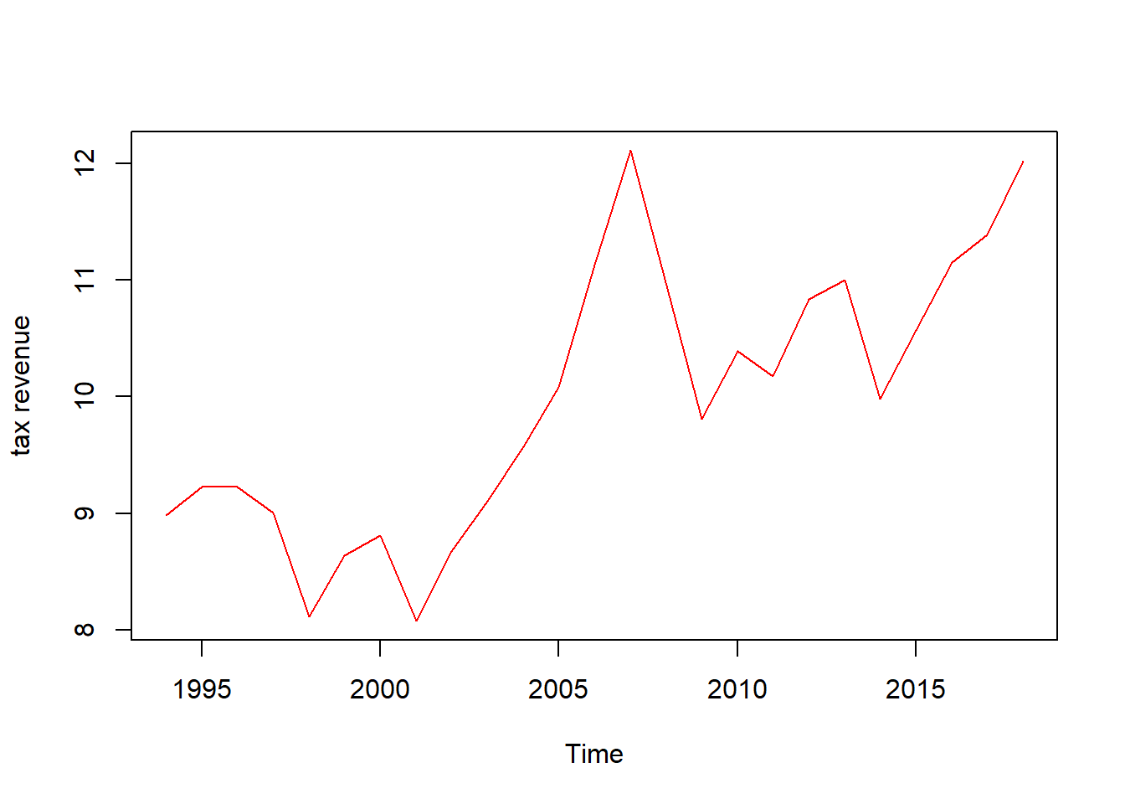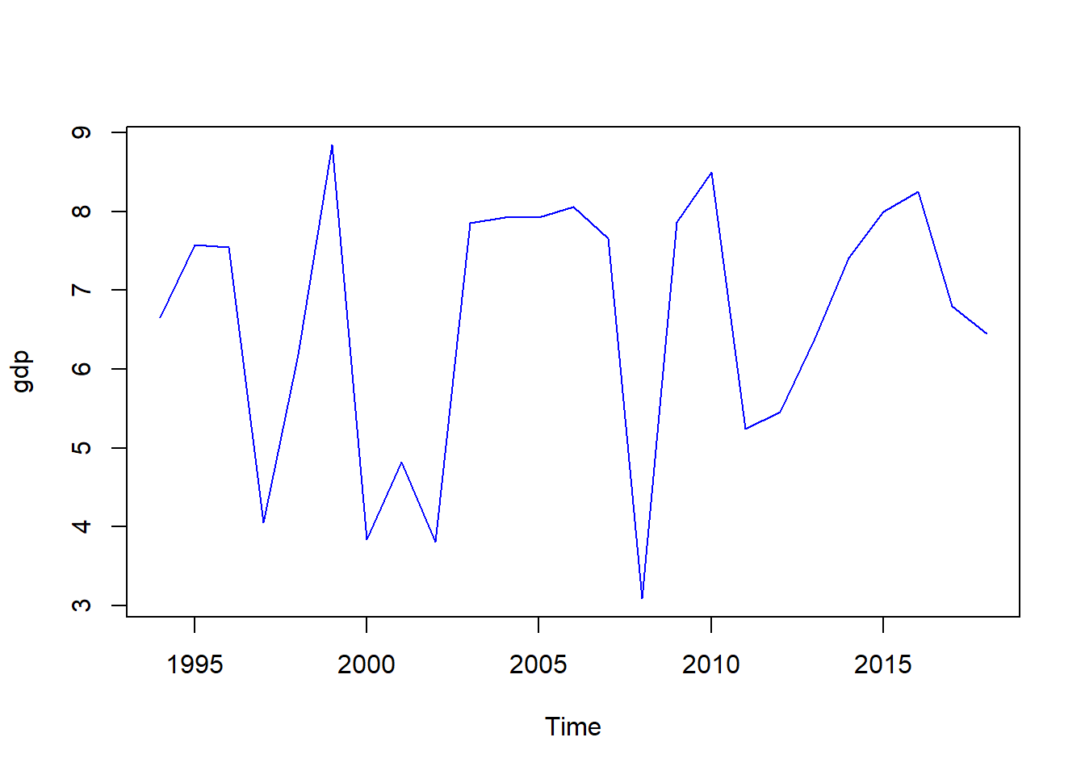

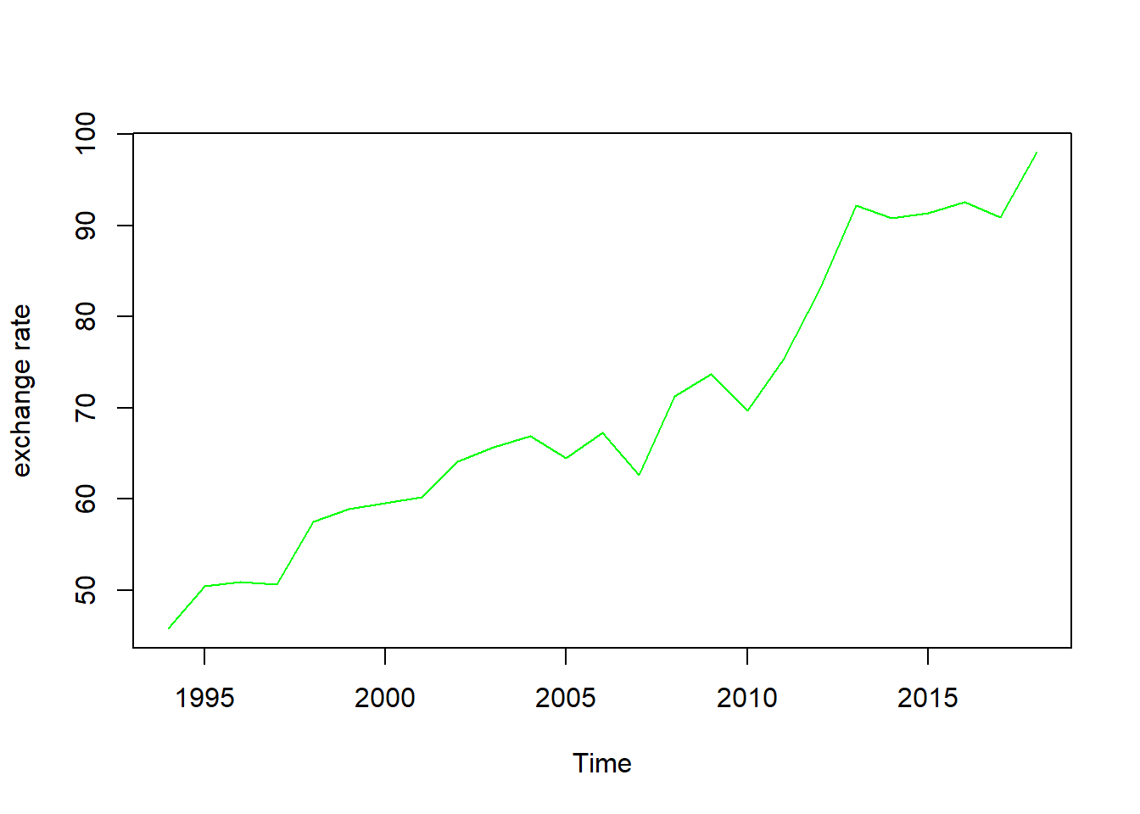 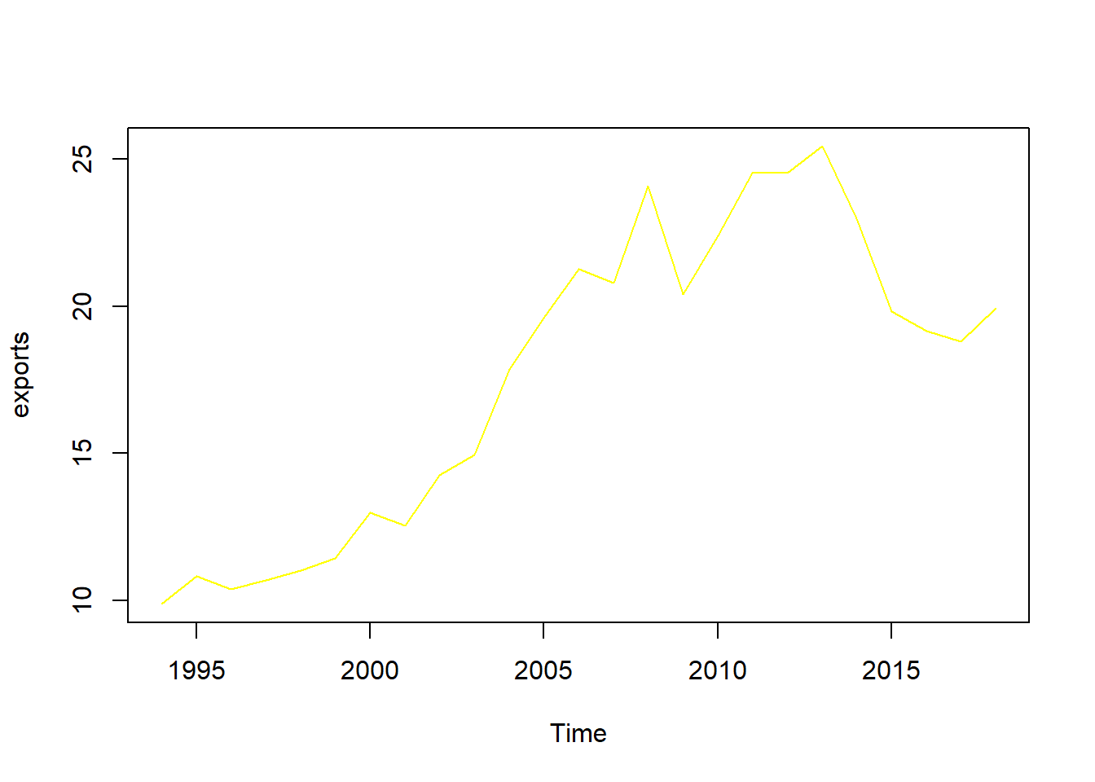

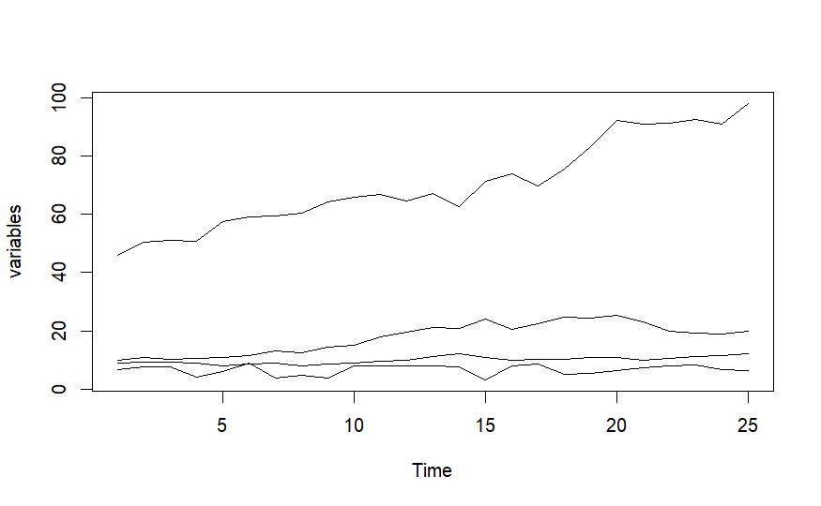

$${GDP}_{t}= {α_{0}+α_{1}TAX}_{t}+α_{2}{ER}_{t}+α_{3}{NX}_{t}+ μ_{t}$$

Where, GDP = Growth rate of Gross Domestic Product

TAX = Tax Rate of India

ER = Exchange Rate

NX = Net Exports

Here, the Growth rate of GDP is taken as the dependent variable, and TAX, ER, and NX are taken as independent variables.

We used the ARDL model, also known as bounds, which was proposed by Pesaran and Shin (1998) and Pesaran, Shin, and Smith (2001) to investigate how GDP growth reacts to TAX, ER, and NX. We employed the ARDL approach for several reasons. The ARDL model allows for I (0) variables in the model. Secondly, because the ARDL model has only a single equation, it is easy to interpret. Third, the ARDL model uses a sufficient number of lags to capture the data-generating process in a general-to-specific modeling framework (Laurenceson and Chiai, 2003). Finally, the ARDL model manages both long-run cointegration and short-run dynamics. After ensuring the number of lags used in the model, we formulated and estimated an unrestricted error correction model as follows:

Converting the model to log

$$ln{GDP}_{t}= {α_{0}+α_{1}lnTAX}_{t}+α_{2ln}{ER}_{t}+α_{3ln}{NX}_{t}+ μ_{t}$$

The above Econometric equation converted into ARDL form:

$$∆{GDP}_{t}= β_{0}+ \sum_{i=1}^{m}{α_{2i}∆{GDP}_{t-i}+}\sum_{i=1}^{n}{α_{3i}∆{TAX}_{t-i}+}\sum_{i=1}^{p}{α_{4i}∆{ER}_{t-i}+}\sum_{i=1}^{q}{α_{5i}∆{NX}_{t-i}+}γ_{1}{GDP}_{t-1}+ γ_{2}{TAX}_{1t-1}+γ_{3}{ER}_{2t-1}+γ_{4}{NX}_{3t-1}+e_{t}$$

*Results and Discussions*

Table 1

Philips-Perron Test

|  |  |  |  |  |
| --- | --- | --- | --- | --- |
| Variables | Level/1st diff | Z-alpha | P-value | Conclusion |
| GDP | Level | -21.779 | 0.01416 | I(0) |
| TAX | 1st Diff | -20.814 | 0.01973 | I(1) |
| ER | 1st Diff | -25.813 | 0.01 | I(1) |
| NX | 1st Diff | -28.701 | 0.01 | I(1) |

Table (I) indicates the stationarity of the variable through the PP( Philips-Perron) test, which explains that Gross Domestic Product (GDP) is integrated of order zero I(0), while tax rate, exchange rate, and net exports are integrated of order zero I(1).

The auto ARDL model provides a best model that is GDP- 1, TAX- 0, EX- 2, NR-0.

Table 2

ARDL Test

|  |  |  |  |  |
| --- | --- | --- | --- | --- |
| Variable | Coefficients | Std. error | T-statistic | Probability |
| C | 2.6754 | 2.2141 | 1.208 | 0.243 |
| GDP | 0.2142 | 0.8520 | 0.869 | 0.396 |
| TAX | -1.1897 | 0.9669 | -1.203 | 0.243 |
| ER | 0.1963 | 0.5453 | 0.360 | 0.723 |
| NX | 0.2536 | 0.4379 | 0.579 | 0.570 |

Table (II) indicates that GDP is the dependent variable while tax, exchange rate, and trade net exports are the explanatory variables. In the above table variable tax shows negative relation but significant impact on economic growth of India. That is 1% increase in tax rate leads to decrease GDP by 0.096%. ER and NX have positive impact.

Bounds Test tells us that there is a possible cointegration.

*Conclusion*

Results of the whole study shows that the taxesrate have negative impact and significant on economic growth both in short run and long run, while high Exchange rate and Net exports leads to higher significant in economic growth in both short run and long run.

# References

Abu-Bader, S. (n.d.). Government expenditures, military spending and economic growth: causality evidence from Egypt, Israel, and Syria.

Alan J. Auerbach, Y. G. (n.d.). Measuring the Output Responses to Fiscal Policy.

Backhouse, R. E. (n.d.). Samuelson, Keynes and the Search for a General Theory of Economics.

Barro, R. J. (n.d.). Government Spending in a Simple Model of Endogeneous Growth.

Carvelli, G. (n.d.). The long‑run efects of government expenditure on private investments: a panel CS‑ARDL approach. *Journal of Economics and Finance (2023)*.

Claeys, P. (n.d.). Policy mix and debt sustainability: evidence from fiscal policy rules.

Emanuele Baldacci, B. C. (n.d.). Social Spending, Human Capital, and Growth in Developing Countries.

Jellal, S. A. (n.d.). Foreign Aid Fiscal Policy: Theory and Evidence.

NILOY BOSE, M. E. (n.d.). PUBLIC EXPENDITURE AND ECONOMIC GROWTH: A DISAGGREGATED ANALYSIS FOR DEVELOPING COUNTRIES.

Nwanakwere, J. T. (n.d.). TAX AND ECONOMIC GROWTH IN NIGERIA: .

Odhiambo, S. A. (n.d.). Insurance Policy Thresholds for Economic Growth in Africa.

*RBI Handbook of Statistics*. (n.d.). Retrieved from Reserve Bank Of India: https://rbi.org.in/Scripts/AnnualPublications.aspx?head=Handbook%20of%20Statistics%20on%20Indian%20Economy

Roel M.W.J. Beetsma, H. J. (n.d.). Monetary and fiscal policy interactions in a micro-founded model of a monetary union.

Simplice A. Asongu, O. E. (n.d.). The long run stability of money demand in the proposed West African monetary union.

Sousa, A. A. (n.d.). The macroeconomic effects of fiscal policy in Portugal: a Bayesian SVAR analysis.

Stephen Taiwo Onifade, S. Ç. (n.d.). An empirical retrospect of the impacts of government expenditures on economic growth: new evidence from the Nigerian economy.

Yadawananda Neog, A. K. (n.d.). Tax structure and economic growth: a study of selected Indian states.